Name: Sethukumar Moorthy

Reg.no: 12307650

Roll No: K23FSB26

1. Problem Statement

Design a network for an 8-floor office building where each floor has different network topologies. The network must incorporate IPv4 addressing, routing, and inter-floor connectivity. The requirements are as follows:

Floors 1–3: 7 computers each (Hybrid Topology with switches and hubs)

Floors 4–6: 7 computers each (Mesh Topology with switches)

Floors 7–8: 7 computers each (Bus Topology with hubs)

The network should use Class A IPv4 addressing and dynamic routing for inter-floor communication.

Physical Implementation:

Used Switch PT, Hub PT, connecting wires include cross and straight cables, pcs, laptops, routers, labels.

Whole structure

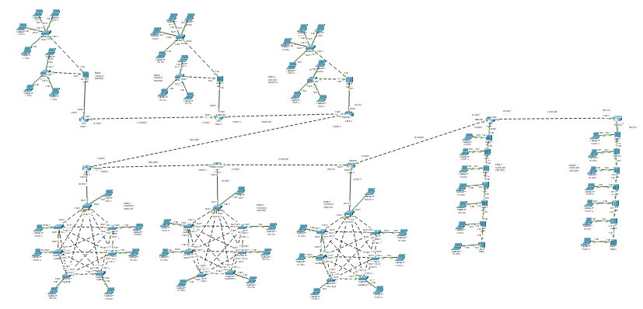

Floor 1-3 design (Hybrid topology)

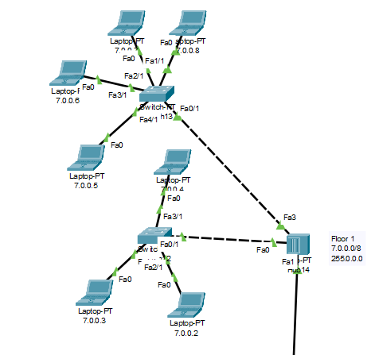

Floor 4-6 design(Mesh)

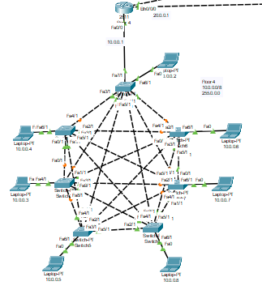

Floor 6-7 design(Bus)

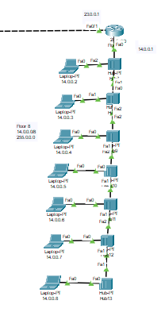

Router IP implementation use CLI commands

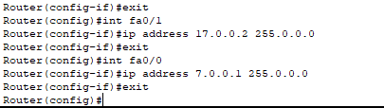

PC IP implementation using UI

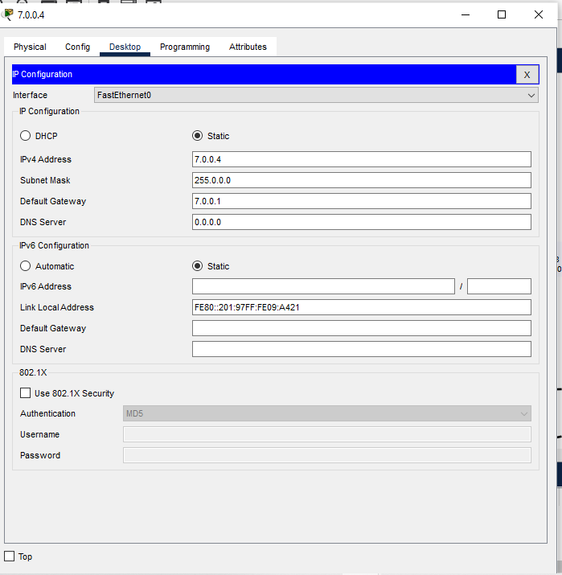

Connections between floors

Floor 1-6

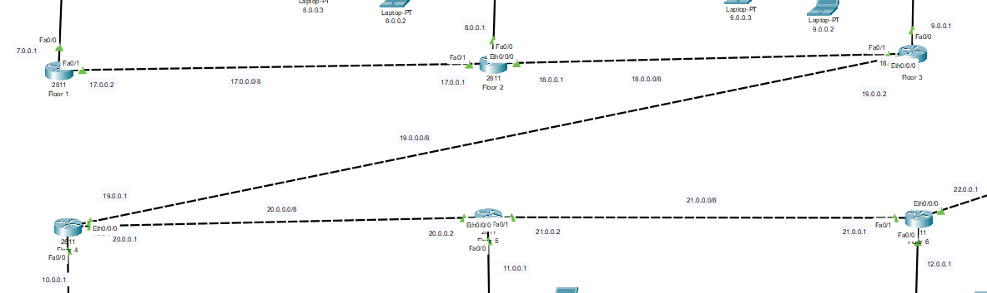

Floor 6-8

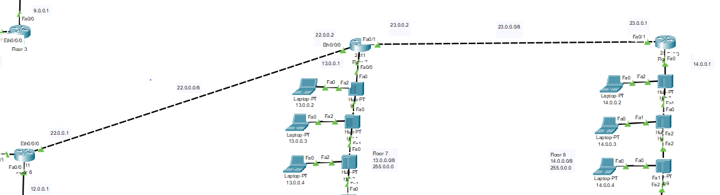Routing method using UI  
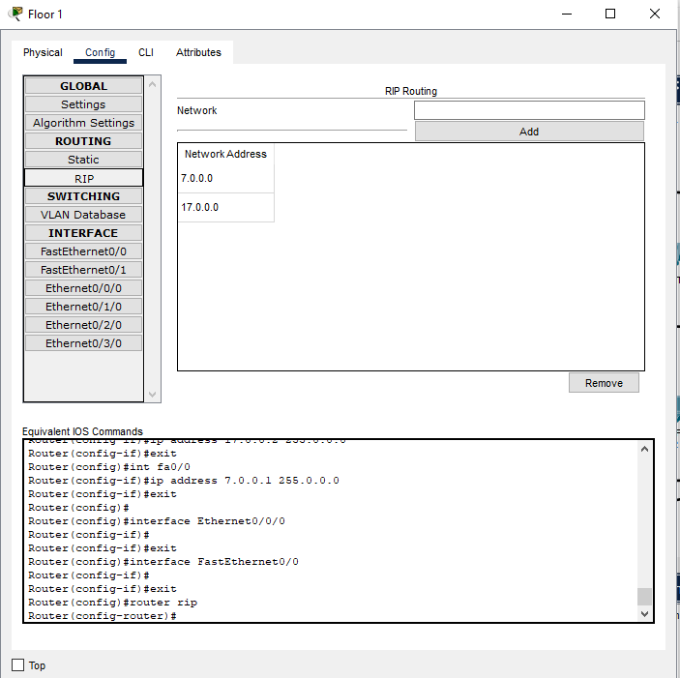

Routing method using CLI

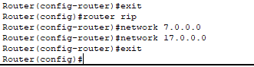

Some Communication Snippets

Communication is implemented using ping <target_ip_address> command in cmd

